# CS 255 Business Requirements Document

**System Components and Design**

**Purpose**

* The purpose of this project is to design an online system for DriverPass that enables customers to:
  + Register and schedule driving lessons.
  + Access online learning materials and practice tests.
  + Manage their accounts and payments.
* DriverPass wants the system to streamline training for driving exams by combining online practice exams with on-the-road training scheduling.

**System Background**

* DriverPass aims to address a market gap where students are not prepared for driving tests.
* Current problems:
  + High failure rates on driving tests.
  + No centralized online platform combining online exams and driving session reservations.
* Needed Features:
  + Online customer registration.
  + Lesson scheduling system.
  + Online classes and practice test modules.
  + Payment processing.
  + Admin and IT management backend.
  + Tracking and activity reports.

**Objectives and Goals**

* The system should:
  + Allow students to register and manage their appointments online.
  + Facilitate secure online payment processing.
  + Provide access to online learning modules and tests.
  + Enable real-time tracking of reservations and changes.
  + Generate activity logs and reports.
  + Maintain compliance with DMV updates.

**Requirements**

**Nonfunctional Requirements**

**Performance Requirements**

* Web-based, cloud-hosted application.
* Must allow real-time access and updates.
* Capable of handling multiple concurrent users.

**Platform Constraints**

* Accessible on all major browsers (Chrome, Firefox, Edge, Safari).
* Compatible with Windows, macOS, iOS, and Android devices.
* Backend database for storing user, schedule, and transaction data.

**Accuracy and Precision**

* Unique user accounts with role-based access.
* Case-sensitive login credentials.
* Immediate notification for any failed login attempts.

**Adaptability**

* Admin interface must allow enabling/disabling service packages.
* IT admin needs full access to user management and system configurations.
* Ability to add DMV updates without major code changes.

**Security**

* Secure login with encryption.
* HTTPS for all communications.
* Account lockout after multiple failed login attempts.
* Password reset functionality.

**Functional Requirements**

* The system shall allow users to create and manage their accounts.
* The system shall enable customers to schedule, modify, or cancel driving lessons.
* The system shall allow customers to select from predefined training packages.
* The system shall process and securely store payment information.
* The system shall provide online access to practice tests and course materials.
* The system shall enable administrators to generate activity reports.
* The system shall allow IT administrators to manage users and permissions.
* The system shall sync with DMV updates and notify users of changes.

**User Interface**

* Customer interface:
  + Account registration and login.
  + Scheduling and payment portal.
  + Access to online classes and tests.
* Admin interface:
  + Customer and schedule management.
  + Reports generation.
  + System settings management.
* Interfaces must be responsive and mobile-friendly.

**Assumptions**

* Customers have internet access and basic computer literacy.
* DMV provides accessible and timely updates.
* Users will primarily interact with the system via web browsers.

**Limitations**

* Budget constraints may limit initial feature rollouts.
* Staff training required for system administration.
* Future package customizations require development resources.

**Gantt Chart**

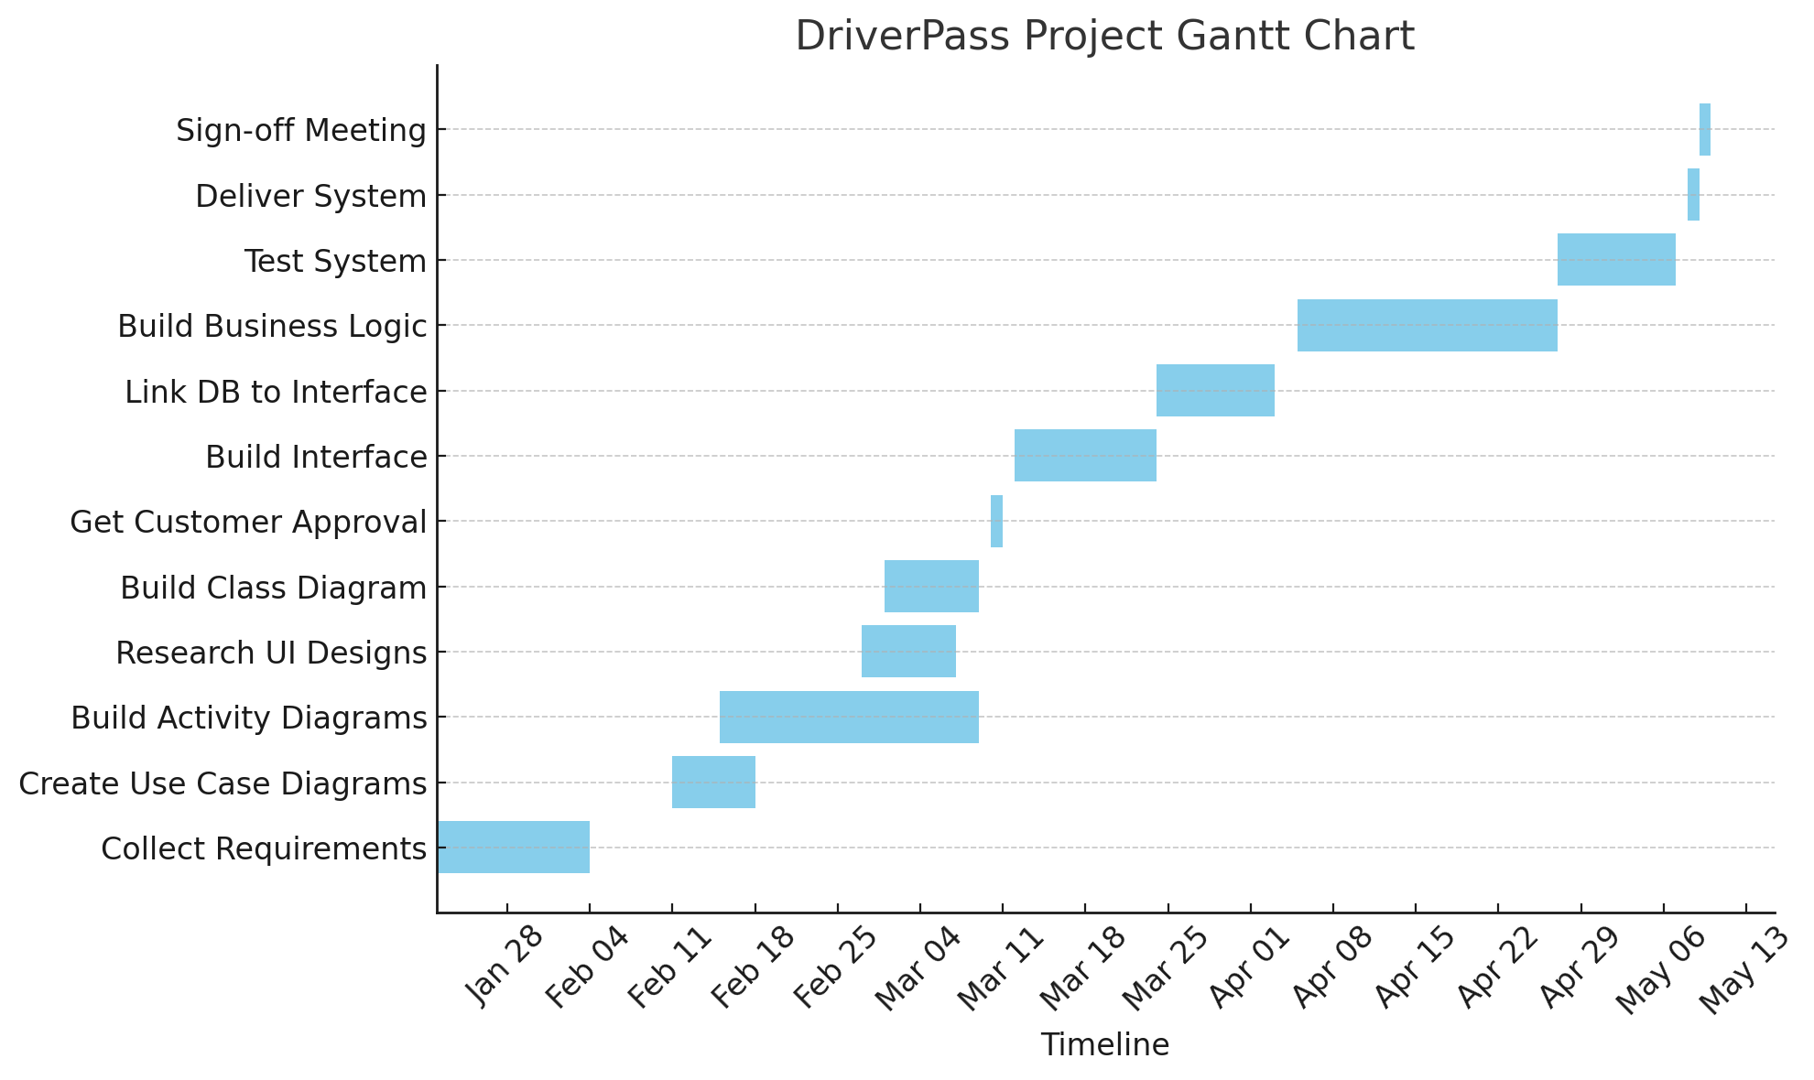

**Gantt Chart (Outline)**

* Collect Requirements: Jan 22 - Feb 4
* Create Use Case Diagrams: Feb 11 - Feb 18
* Build Activity Diagrams: Feb 15 - Mar 9
* Research UI Designs: Feb 27 - Mar 7
* Build Class Diagram: Mar 1 - Mar 9
* Get Customer Approval: Mar 10 - Mar 11
* Build Interface: Mar 12 - Mar 24
* Link Database: Mar 24 - Apr 3
* Build Business Logic: Apr 5 - Apr 27
* Test System: Apr 27 - May 7
* Deliver System: May 8 - May 9
* Sign-off Meeting: May 9 - May 10